GRANDMASTER RICHARD “HUK” PLANAS MERCHANDISE ORDER FORM
Please print this order form and send to the following address-

Mr. Richard Planas
3412 N. Woodlawn Avenue, #3
Metairie, LA 70006
United States of America

Please make the check or money order payable to
Richard Planas, not Huk Planas.

Thank you.

NAME: ________________________________________________

STREET ADDRESS: _____________________________________

_______________________________________________________

CITY: _________________________________________________

STATE: _______________________________________________

ZIP CODE: _____________________________________________

TELEPHONE: __________________________________________

E-MAIL: _______________________________________________

DESCRIPTION PRICE QUANTITY TOTAL

Complete Collection $520.00 X ___________ = $____________
- Volume 1 through 13
Volume 1 $40.00 X ___________ = $____________
- Beginning Basics and Fundamentals of Kenpo
Volume 2 $40.00 X ___________ = $____________
- Yellow Belt Techniques and Family Groupings
Volume 3 $40.00 X ___________ = $____________
- Short Form 1 and Long Form 1
Volume 4 $40.00 X ___________ = $____________
- Short Form 2 and Finger Set
Volume 5 $40.00 X ___________ = $____________
- Long Form 2
Volume 6 $40.00 X ___________ = $____________
- Short Form 3
Volume 7 $40.00 X ___________ = $____________
- Long Form 3
Volume 8 $40.00 X ___________ = $____________
- Form 4: Part 1
Volume 9 $40.00 X ___________ = $____________
- Form 4: Part 2
Volume 10 $40.00 X ___________ = $____________
- Form 5: Part 1
Volume 11 $40.00 X ___________ = $____________
- Form 5: Part 2
Volume 12 $40.00 X ___________ = $____________
- Form 6: Part 1
Volume 13 $40.00 X ___________ = $____________
-Form 6: Part 2
Two Man Set $40.00 X ___________ = $____________

Problem Techniques $40.00 X ___________ = $____________
SUBTOTAL $____________

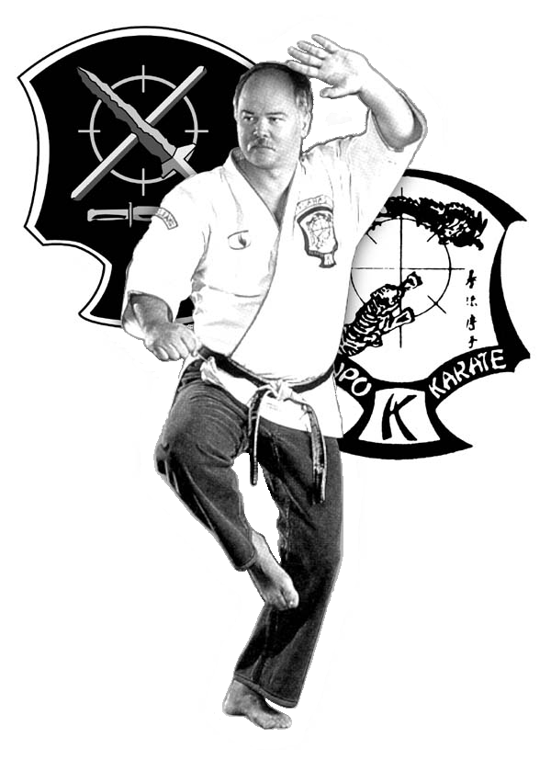
SHIPPING & HANDLING $6.00 FOR 1ST DVD, $1.50 FOR EACH ADDITIONAL $____________

TOTAL $____________

